A Proposal for a Short Film (FMP)
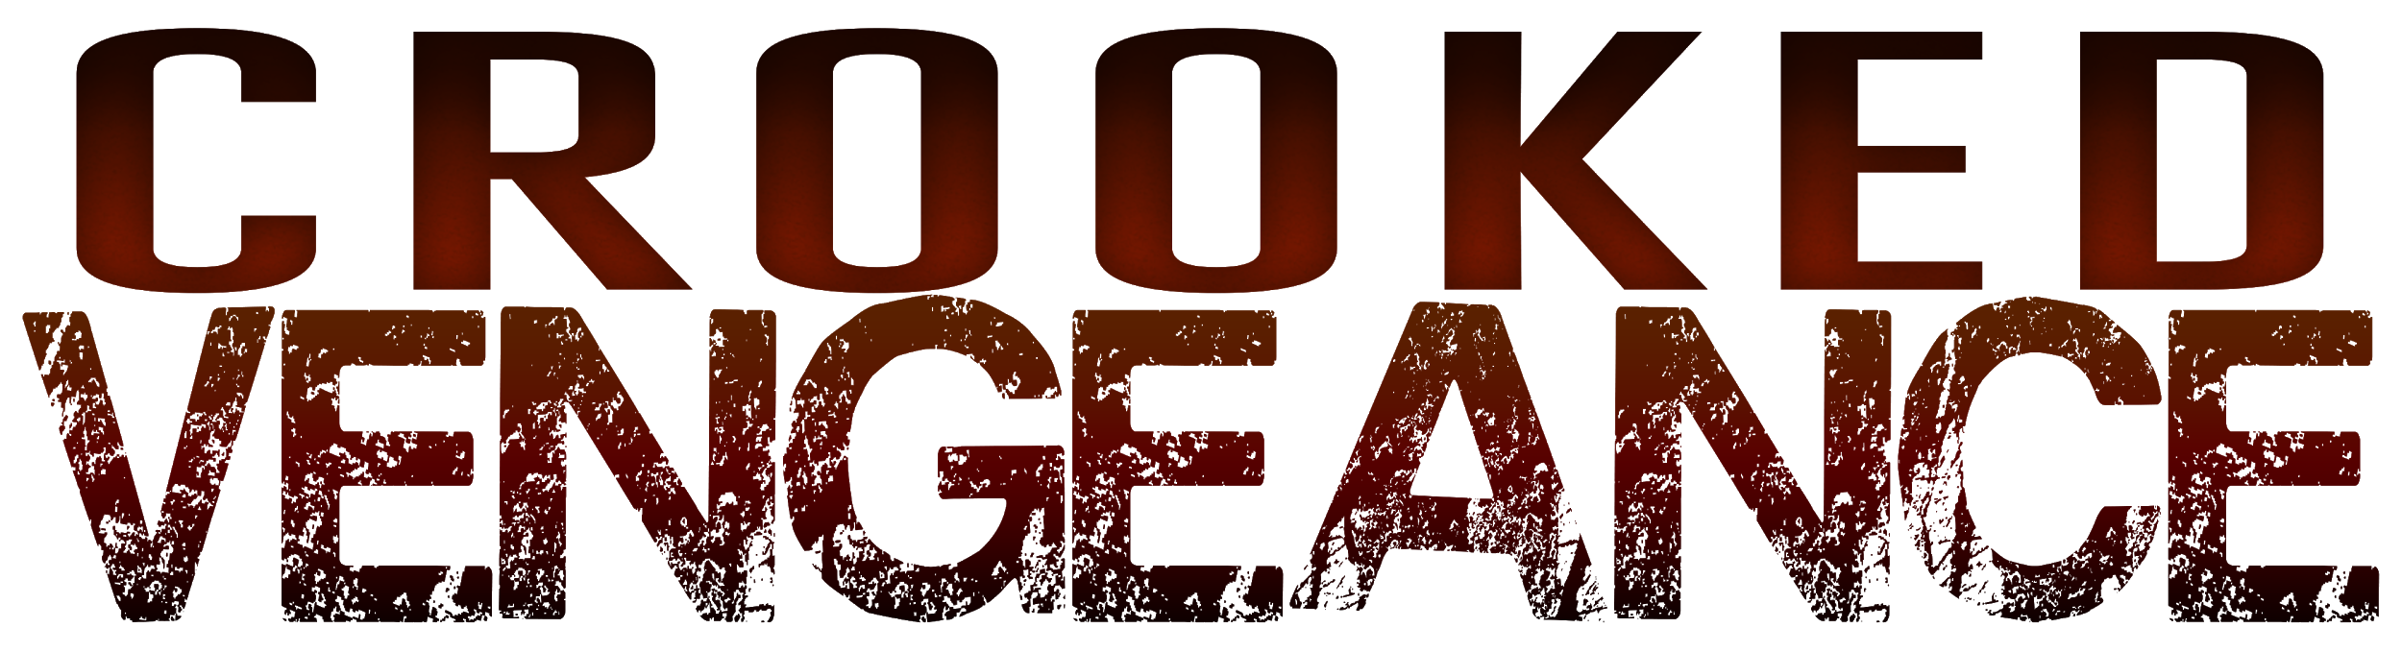
Prepared by Sophia Barnfather & Jake Mason
01/04/18
PROPOSAL
Logline
Doubting his criminal lifestyle and tormented by betrayal, Bernie seeks revenge on his treacherous former partner, whilst trying to win the heart of lawful Charmaine.
Tagline
Revenge isn’t always sweet
Overview
We will be creating a crime/drama 20 minute short film.

Synopsis
Bernie seeks revenge on Roger, his former deceptive criminal partner. Although Charmaine, intimately pursued by Bernie, is eager for him to leave his unlawful life in the past. However Bernie cannot get over Roger’s betrayal and has been waiting for his time to act on his revenge. When Bernie hears of a large farmhouse being targeted by Roger, he decides this is his time to launch a vengeful attack.
Character Briefs
Our character briefs are included in a separate document enclosed in the proposal pack.
Message of the film
We plan to entertain an audience while providing a moral message drawn from our inspirations. The message of our short film is that revenge doesn’t always make you happy and can hurt those you are closest to.
Purpose
Our short film’s purpose is to be hosted on streaming sites such as Amazon Prime to make a profit. We will also enter our film into short film competitions to raise our film’s status and gain more exposure.
Feasibility
We will be hiring camera equipment, sound equipment and lighting equipment in order to make the film. We have several actors interested in the project, they are willing to be paid the agreed rates on the budget. In our proposal pack we have included a budget detailing our predicted spending with the money we are asking for. With our research and experience we have fully taken into account our budget which we think is certainly adequate for our film. We have included contingency figures in our budget to safeguard against any possible issues.
Research results
We have started various research documents that are included in our proposal pack.

Examples of similar films/short films
Many other crime thrillers would be similar to our film such as: Seven (1995), Reservoir Dogs (1991), Lock, Stock and Two Smoking Barrels (1998) and Pulp Fiction (1994).
Style inspiration
We will be using music from blues origins, as well as alternative and orchestral soundtracks, which have inspired the mood. The genre is inspired by Guy Richie’s style of filmmaking, while the visuals are inspired by Spielberg’s camera movement and Roger Deakins’ lighting.
Target audience
Our target audience will mainly be white males aged around 18-30 years old. They will mostly be in socioeconomic group E and will be interested in action/crime movies such as Pulp Fiction.
Cast
Bernie -- Jimmy Edwards
Roger -- Will Smart
Mark -- Morgan Orme
Gerald -- George D’Rozario
Charmaine -- Georgia Middle
Mary -- Ella Cakebread
Crew
Writer/Director -- Jake Mason
Producer/Sound -- Sophia Barnfather
Editor -- Brandon Shears
Cinematographer -- Dan New (Kirkwood)
Transport -- Morgan Orme
Makeup -- Ella Winterbourne
Locations
25 Charlton Road, Weston-super-Mare, BS23 4HG
2a Park Road, Congresbury, BS429 5HN
Locking Castle District Centre, Weston-super-Mare BS24 7AY
Sims Hill, Ropers Lane, Wrington, BS40 NH
Bell Inn, 1 The Square, Banwell BS29 6BL
Purn House, Purn Way, Bleadon, Weston-super-Mare BS24 0QE
Equipment
Camera | Canon EOS C100, Rails/Follow Focus + Atomos Shogun
Grip | Manfrotto Tripod (counterbalance head) + Gimbal + Slider + Mini Jib
Lighting | LED Panel + LED Spot + 400w Flood + Coloured Gels + 5 in 1 Reflector
Sound | H4N Pro + Rode NTG-3 Microphone + Boom Pole + Blimp (with deadcat)  2x Omnidirectional Audio Technica Microphones
Conclusion
In conclusion this project is very close to our hearts, because we ourselves believe we are the target demographic. We make films that we ourselves would like to see.

